JECRC 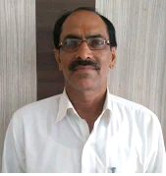
JAIPUR

INDIVIDUAL Lab Instructor DATA SHEET
Name of the Lab Instructor | : | Babulal sharma
Present Designation | : | Lab technican
Email Id:
Contact Details:

I. Particulars of Educational Qualification: (only completed)

Category | Name of the Degree | Specialization | Year of Passing | Name of the College | Name of the University
UG | B. A | PUBLIC ADMINSTRATIVE | 2013 | RAJSTHAN UNIVERSITY JAIPUR | RAJSTHAN UNIVERSITY JAIPUR
PG
diploma | Diploma | Radio and telivison | 1983 | BISR | BIRLA INSTITUE

II. Academic Experience : 14 YEAR

III. Industrial Experience :15 YEAR

IV. Awards/Achievements :

VI. Research/Specialization : PROJECT

VII. Course Taught :

